Hello !
First of all i want to thank you for buying my product! if u find any issues or have any sugestion Please contact me at Wao3dStudio@gmail.com

V2.1
Fixed the pink wings issue from upgrading to unity 2018.
V2

*In this update i have worked on a special shader that combines the RGB color to achive diferent butterflies colors (someone asked for yellow butterflies so i decided to make this shader , this way you can make them yellow, green blue, red, etc...)

*Something that i was looking to implement a long time ago , and this was possible thanks to Satwant Singh for making this wonderful C# Flock Script , you can see his work at https://www.youtube.com/user/sskenth or @satwantsk .
To use the script just create an empty object in your scene and add the Global Flock Script to it , in the script you need to select one butterfly prefab to be spawn, now add the Flock Script to the prefab butterfly that you selected in the Global Flock.

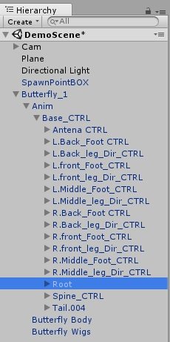
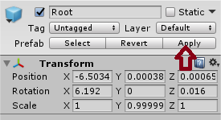
To add the Spark particles to your butterflies open the butterflie hierarchy -Anim\Base_CTRL\Root drag and drop the spark particle in the Root now apply and save the butterflie prefab .

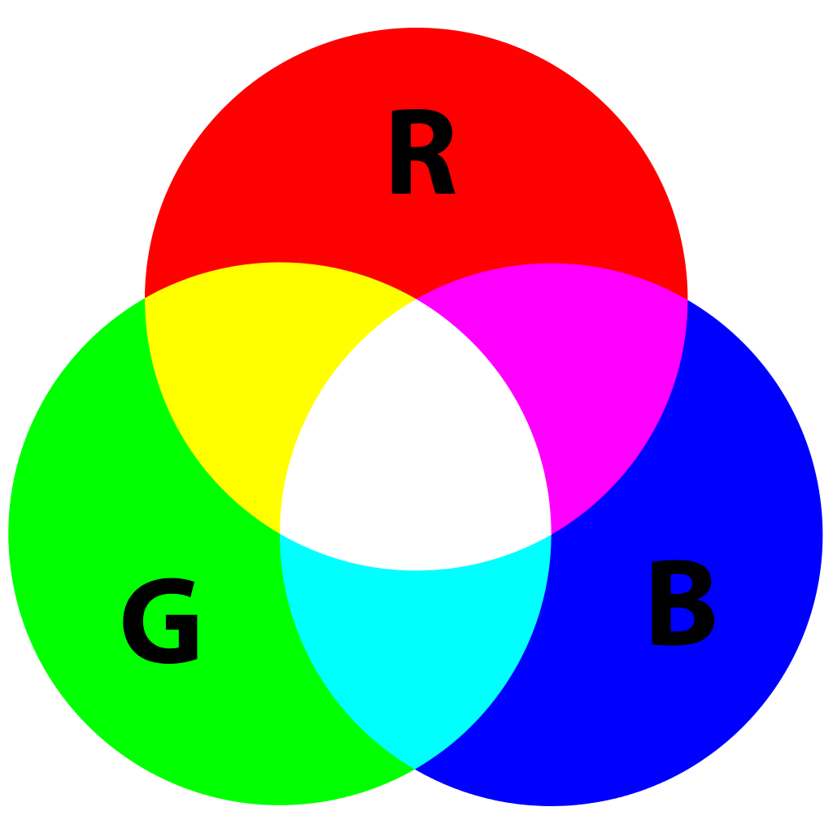
About the Shader.
The shader combines the RGB Colors from the base Difuse texture to create diferent colors

How it works.
Just activate the boolean on-off , so the effect take place, and play with the colors.

